Adult
Realistic Drawing and Painting
Workshop

With Natick Artist/Teacher

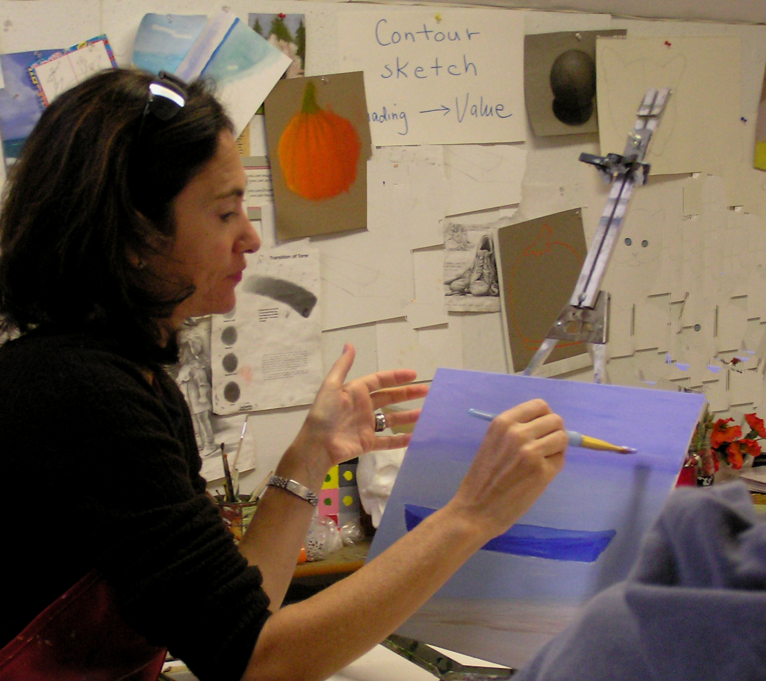
Teresa Higgins
2014-15

Thursdays 7:00-9:00 p.m.
A

We will create still lifes, seascapes, portraits and
landscapes from photos and from life.
A variety of mediums will be provided
including pastels, acrylics, charcoal and oils.
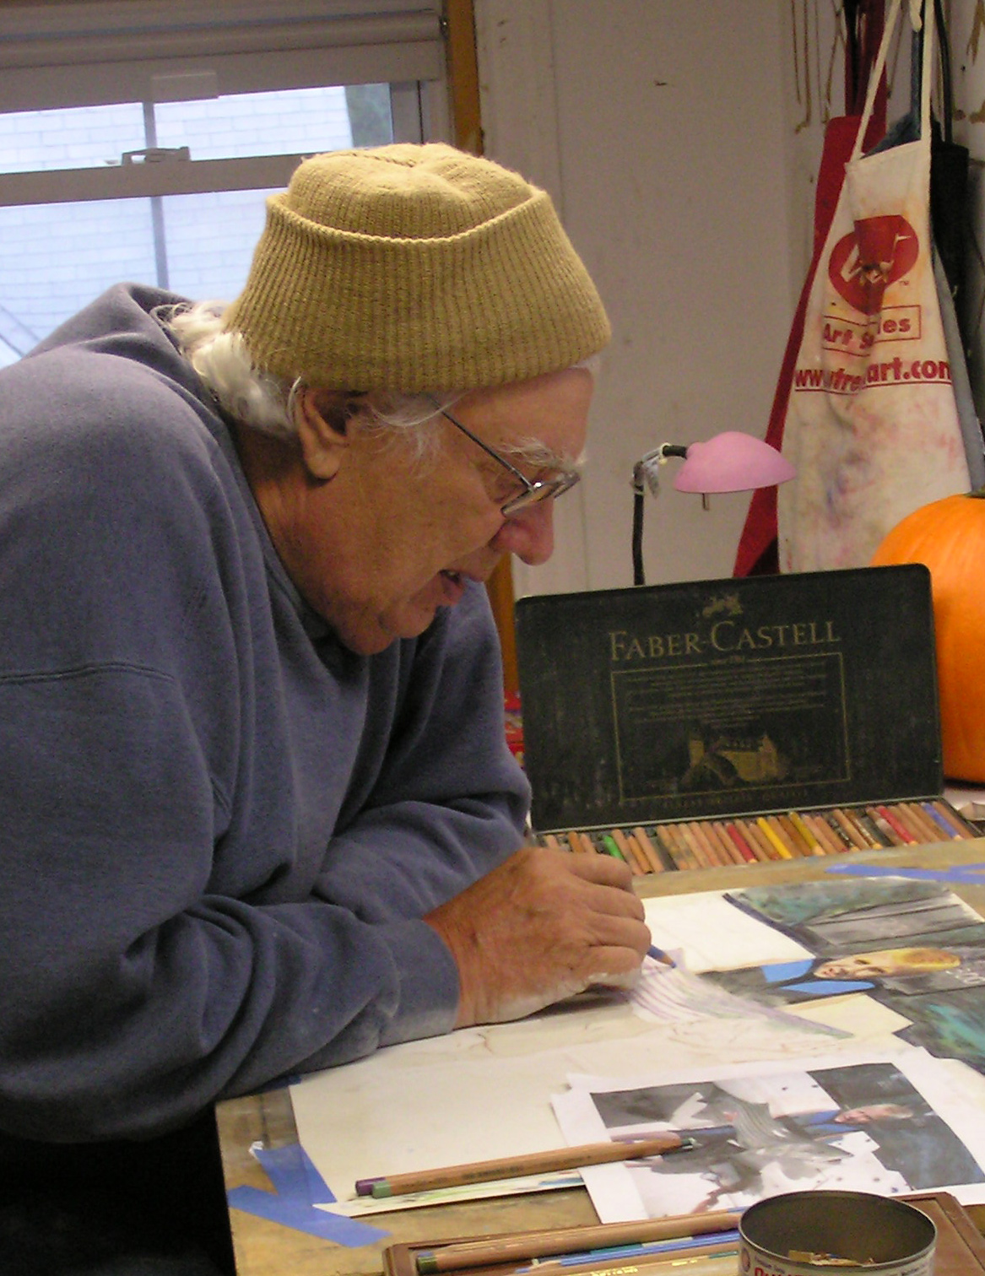
I will address:

1.Basic principles of drawing (Contour,Values, Proportion, Perspective,Composition)
2.Traditional painting techniques with pastels and oils
3 Creating effective colors with pastels and oils

Location: My studio at 18 Reynolds Avenue Natick MA.

Class Size: Limited to 7 (minimum of 3)
Tuition: $220.00 (including all materials except canvas larger than 11x14 )

Objective: Creativity and Fun
Call: (508) 652-0713
Email: thigginsart@gmail.com
Visit: TeresaHiggins.com
Registration: (Complete this form and mail with tuition to: Teresa Higgins 18 Reynolds Ave.
Natick, MA 01760)

Name_______________________________________Phone____________________Email_______________

Address______________________________________________________zip code_____

May 7-June 11___, June 18-July 16___

(There are no refunds or credits for missed classes. )

